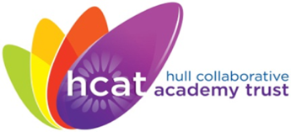Hull Collaborative Academy Trust

**JOB ADVERT**

**HCAT Central Team -**

**Governance Professional   
Grade 8, Point 25 – 28   
(£33,945 - £36,648 FTE)**

**37 hours per week**

**Term-time, plus ten days (200 days)**

**Permanent contract**

We are looking to recruit a dynamic, enthusiastic and knowledgeable Governance Professional to join the Central Team of Hull Collaborative Academy Trust.

Occupying a key role within the organisation, the post holder will be responsible for maintaining the highest standards of Trust governance. Managing the interface between the Trust Board, it's sub-committees and senior managers to facilitate the smooth operations of the Trust's formal decision making and reporting processes.  A key aspect of the role is ability to forward plan and support a range of committee meetings ensuring these are accurately and concisely recorded.  The post holder will also be expected to advise on key areas of governance and legislation to ensure all meetings are conducted in a compliant manner.

The role will lead on the process of recruiting, inducting and training Members, Trustees and any other committee members.

If you would like any further information or for an application pack, please contact the HCAT HR & Recruitment Advisor via email on XXXXXXXXXXXX

**Closing Date for applications**: Friday 10th January 2025, at 5.00pm   
**Interviews:** w/c 13th January 2025

**The school is committed to safeguarding and promoting the welfare of children and young people and expect all staff and volunteers to share this commitment. This post is exempt from the Rehabilitation of Offenders Act 1974 so is subject to a satisfactory enhanced Disclosure and Barring Service criminal records check for work with children. This post involves contact with children in a school setting and has safeguarding responsibilities.  
As part of our safer recruitment procedures, online checks (including social media) may be carried out by the Trust, through the shortlisting process.**