ADVERT
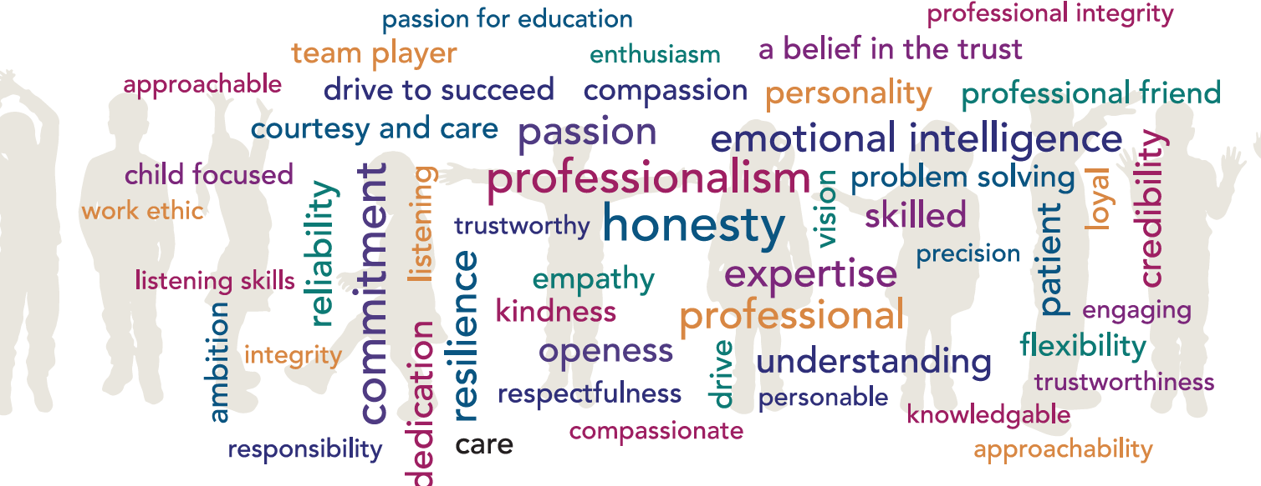

ROLE: LGC Governance Professional (1 BCP/Dorset area & 2 Southampton area)
SCHOOL: 2 -3 schools BCP or Southampton areas
HOURS: Approx. 60 hours per school per year to cover 6 meetings for each local governing committee with meeting times starting late afternoon / early evening during the school term plus 10 personal training hours
SALARY: Grade 6 (£26,609 to £28,770 FTE) ACTUAL SALARY £2,062 to £2,296 (for 2 schools) or £3,015 to £3,357 (for 3 schools)
CLOSING DATE: Friday 19th July 2024, 12 noon (This may close early if we successfully appoint prior to this date)
INTERVIEW DATE: To be arranged on an individual basis
START DATE: September 2024

JOB/PERSON SUMMARY:
Using your experience as an excellent administrator you will play a vital role in organising local governing committee meetings, accurately recording their work by producing effective minutes and provide advice and guidance on governance issues.
You will need to be able to work under your own initiative, manage deadlines, update and keep accurate written and electronic records. The ability to remain impartial, comply with data protection legislation and maintain confidentiality is a key part of the role.
Please see the attached job description and person specification for more details about the role.
If you are a positive, flexible individual with strong communication skills, and would relish the opportunity to support our local governing committees to maximise their effectiveness, we would like to hear from you.

WE ARE SEEKING A PROFESSIONAL INDIVIDUAL WHO:
- Is able to prioritise their workload
- Is able to work effectively and independently
- Can build positive working relationships with several different stakeholders

WE CAN OFFER YOU:
- A supportive and welcoming environment in each school where you will be a valued and key part of the governance team.
- Potential to work remotely depending on schools allocated
- Excellent CPD opportunities and Training and Development Programmes
- An individual induction programme supported by a mentor
- Eligibility to join the Local Government Pension Scheme
- Free eye tests up to the value of £25 for users of VDU equipment and contribution up to the value of £60 towards the purchase of glasses specifically for the use of display screen equipment (where all conditions are met)
- Access to the Trust Health and Wellbeing pages
- Access to a staff benefits portal through Vivup
- Free confidential telephone and face to face counselling for staff and family members

APPLICATION PROCEDURE:
Should you wish to apply for this vacancy, please view the job description and complete the application form which can be found at www.hamwic.org/vacancies/managed-services. Completed applications should be returned to recruitment@hamwic.org. CVs will only be accepted with a completed application form.

Please submit your application as soon as possible as we may invite candidates to interview before the closing date.

SAFEGUARDING:
All schools with the Trust are committed to safeguarding and promoting the welfare of children and young people and expect all staff and volunteers to share this commitment.
We will ensure that all our recruitment and selection practices reflect this commitment. All successful candidates will be subject to Disclosure and Barring Service checks along with other relevant employment checks.

THE HAMWIC EDUCATION TRUST:
The Hamwic Education Trust is the Trust for schools that form part of Jefferys Education Partnership, Edwin Jones Partnership, Ridings Partnership, Greenway Partnership, Mayflower Partnership and Hillary Partnership. The Trust and its schools offer unique opportunities for those individuals that excel in education.

We aim to deliver an outstanding education to our pupils and to do so we must employ outstanding people.
We offer a training pathway for all employees including teachers, support staff and our middle and senior leaders.

Our staff have opportunities to work on cross phase projects and to work in other schools within the Trust in order to gain invaluable experience and enhance their skills.

